|  |  |  |
| --- | --- | --- |
| **Tech Saksham**  Final Project Report  **Track Name** |  |  |

**“Virtual Clothing Try-On”**

**“Avanthi Institute Of Engineering & Technology”**

|  |  |
| --- | --- |
| **ROLL NO** | **NAME** |
| 19Q61A0475 | Punna Srija |
|  |  |
|  |  |
|  |  |
|  |  |

|  |  |
| --- | --- |
|  |  |
|  | Trainer Name:  Uma Maheswari |
|  | Master Trainer |

**ABSTRACT**

**Virtual Clothing Try-On: Revolutionizing Online Shopping**

Online shopping has become increasingly popular in recent years, and it's no surprise why. It's convenient, easy, and offers a wide range of products from the comfort of your own home. However, there's one issue that remains - how can online shoppers be sure that what they're purchasing will fit them correctly and look good on them? Enter virtual clothing try-on, an HTML-based application that allows users to upload an image of themselves and try on different outfits virtually.

The benefits of virtual clothing try-on are many. For one, it eliminates the need to physically go to a store and try on clothes. This is particularly beneficial for those who live in rural areas or have mobility issues. Additionally, it saves time and money by reducing the number of returns due to sizing or style issues. By seeing how the clothes look on them before making a purchase,users are less likely to buy something that doesn't fit or doesn't suit their style.

Implementing virtual clothing try-on is relatively simple. An HTML-based application can be created that allows users to upload an image of themselves and then superimpose clothing items over the image. The application could be integrated into an existing e-commerce website or offered as a standalone tool. The technology required for this is already available, and it's only a matter of time before it becomes a standard feature on many e-commerce websites.

Of course, there are some potential drawbacks to virtual clothing try-on. For example, the technology may not be perfect, and the clothing may not look exactly the same on the virtual avatar as it does in real.

**INDEX**

|  |  |  |
| --- | --- | --- |
| **Sr. No.** | **Table of Contents** | **Page No.** |
| 1 | Chapter 1: Introduction | 1-5 |
| 2 | Chapter 2: Services and Tools Required | 6 |
| 3 | Chapter 3: Project Architecture | 7-8 |
| 4 | Chapter 4: Architecture Blocks Detail Working | 9 |
| 5 | Conclusion | 10 |
| 6 | References | 11 |
| 7 | Code | 12 |

**CHAPTER 1**

**INTRODUCTION**

* 1. **Overview:**

Virtual clothing try-on is a game-changing technology that promises to revolutionize online shopping. With this application, online shoppers can see how a particular piece of clothing will look on them before making a purchase. By using a virtual avatar or uploading a photo of themselves, users can see how clothes would look on their body type and make a more informed decision about what to buy.

The benefits of virtual clothing try-on are many. For one, it eliminates the need to physically go to a store and try on clothes. This is particularly beneficial for those who live in rural areas or have mobility issues. Additionally, it saves time and money by reducing the number of returns due to sizing or style issues. By seeing how the clothes look on them before making a purchase,users are less likely to buy something that doesn't fit or doesn't suit their style.

Implementing virtual clothing try-on is relatively simple. An HTML-based application can be created that allows users to upload an image of themselves and then superimpose clothing items over the image. The application could be integrated into an existing e-commerce website or offered as a standalone tool. The technology required for this is already available, and it's only a matter of time before it becomes a standard feature on many e-commerce websites.

Of course, there are some potential drawbacks to virtual clothing try-on. For example, the technology may not be perfect, and the clothing may not look exactly the same on the virtual avatar as it does in real.

* 1. **Feature:**

1. **Virtual Avatar:** Users can create a virtual avatar or upload a photo of themselves to superimpose clothing items over the image.
2. **Clothing Selection**: The application allows users to select different clothing items from a variety of options, such as dresses, shirts, pants, and accessories.
3. **Customization:** Users can customize their virtual avatar's size, skin tone, and hair color to make it more accurate to their real appearance.
4. **Fit Assessment:** The application provides a fit assessment of the clothing items, allowing users to see how they will look on their body type.
5. **360-Degree View:** Users can view the clothing items from all angles, giving them a complete picture of how they will look.
   1. **Advantages:**
6. **Convenience:** With virtual clothing try-on, shoppers no longer need to physically visit a store or try on clothes to determine their fit and style. This technology allows users to try on clothes from the comfort of their own homes.
7. **Time-saving:** Virtual clothing try-on reduces the amount of time spent on returns and exchanges. By allowing shoppers to see how clothes look on them before purchasing, they are less likely to buy clothes that don't fit or don't suit their style.
8. **Improved accuracy:** Virtual clothing try-on provides a more accurate depiction of how clothing will look on the user's body, compared to traditional images or descriptions provided by the online store.
9. **Increased confidence:** By seeing how clothes will look on them before purchasing, shoppers can make more confident decisions about what to buy. This can lead to a more positive shopping experience and a higher likelihood of repeat purchases.
10. **Enhanced customization:** Virtual clothing try-on allows users to customize their virtual avatar, providing a more personalized and accurate representation of how clothes will look on them.
    1. **Scope:**
11. **E-commerce**: Virtual clothing try-on can be integrated into e-commerce websites to enhance the shopping experience for customers. It can help reduce returns and increase customer satisfaction, which can lead to higher conversion rates and revenue.
12. **Fashion industry**: The fashion industry can use virtual clothing try-on to showcase new collections and designs, allowing customers to visualize how clothes will look on them before they hit the stores. This technology can also help fashion designers and manufacturers to improve the accuracy and fit of their clothing.
13. **Virtual fashion shows:** With virtual clothing try-on, fashion shows can be conducted virtually, allowing audiences to view clothing items on virtual models in real-time. This can help make fashion shows more accessible and cost-effective.
14. **Healthcare industry:** Virtual clothing try-on can be used in the healthcare industry to assist with prosthetic fittings or to visualize how clothing will fit over medical devices or equipment.
15. **Education:** Virtual clothing try-on can be used in educational settings, such as fashion design courses, to teach students about clothing design, fit, and customization.
    1. **Future Work:**
16. **Improving Accuracy:** While virtual clothing try-on has come a long way, there is still room for improvement in terms of accuracy. Future work could focus on improving the accuracy of the virtual avatar to better represent the user's body type and shape, making the virtual try-on experience even more realistic.
17. **Augmented Reality (AR):** One potential future development for virtual clothing try-on is the use of AR technology. This would allow users to see themselves in the virtual outfit in real-time, using their mobile device's camera. AR technology would provide a more immersive and interactive shopping experience, increasing the potential for customer engagement and satisfaction.
18. **Artificial Intelligence (AI):** AI technology could be used to create more personalized virtual try-on experiences for users. By analyzing a user's body type, style preferences, and previous purchases, AI could recommend outfits and styles that are more likely to suit the user's tastes and preferences.
19. **Sustainability:** As consumers become more environmentally conscious, future work could focus on incorporating sustainable clothing options into virtual clothing try-on applications. This could include virtual try-on experiences for eco-friendly clothing lines, showcasing the environmental impact of clothing production, or incorporating virtual upcycling options into the application.
20. **Integration with Smart Mirrors:** Virtual clothing try-on could be integrated with smart mirrors, allowing users to try on clothes virtually in-store or in their homes. This would provide a seamless and convenient shopping experience for customers, while also allowing retailers to gather data on user preferences and shopping habits.

**CHAPTER 2**

**SERVICES AND TOOLS REQUIRED**

**2.1 Services Used**

HARDWARE REQUIREMENTS:

• System : Pentium IV 2.4 GHz.

• Hard Disk :40 GB.

• Floppy Drive : 1.44 Mb.

• Monitor : 15 VGA Color.

• Mouse : Logitech.

• Ram : 1GB

SOFTWARE REQUIREMENTS:

• Operating system : Windows 10.

• Coding Language : HTML

**CHAPTER 3**

**PROJECT ARCHITECTURE**

**3.1 Architecture**

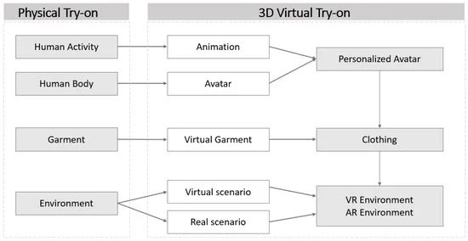

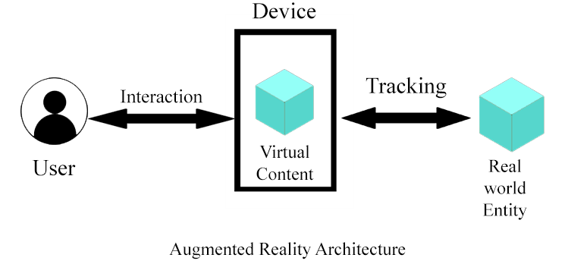

**Integration & Test Stage:**

During the integration and test stage, the software artifacts, online help, and test data are migrated from the development environment to a separate test environment. At this point, all test cases are run to verify the correctness and completeness of the software. Successful execution of the

test suite confirms a robust and complete migration capability. During this stage, reference data is finalized for production use and production users are identified and linked to their appropriate roles. The final reference data (or links to reference data source files) and production user list are compiled into the Production Initiation Plan.

The outputs of the integration and test stage include an integrated set of software, an online help system, an implementation map, a production initiation plan that describes reference data and production users, an acceptance plan which contains the final suite of test cases, and an updated project plan.

**¨ Installation & Acceptance Test:**

During the installation and acceptance stage, the software artifacts, online help, and initial production data are loaded onto the production server. At this point, all test cases are run to verify the correctness and completeness of the software. Successful execution of the test suite is a prerequisite to acceptance of the software by the customer.

After customer personnel have verified that the initial production data load is correct and the test suite has been executed with satisfactory results, the customer formally accepts the delivery of the software.

The primary outputs of the installation and acceptance stage include a production application, a completed acceptance test suite, and a memorandum of customer acceptance of the software. Finally, the PDR enters the last of the actual labor data into the project schedule and locks the project as a permanent project record. At this point the PDR "locks" the project by archiving all software items, the implementation map, the source code, and the documentation for future reference.

**Maintenance:**

Outer rectangle represents maintenance of a project, Maintenance team will start with requirement study, understanding of documentation later employees will be assigned work and they will under go training on that particular assigned category.

For this life cycle there is no end, it will be continued so on like an umbrella (no ending point to umbrella sticks).

**CHAPTER 4**

**ARCHITECTURE BLOCKS DETAIL WORKING**

**4.1 Blocks**

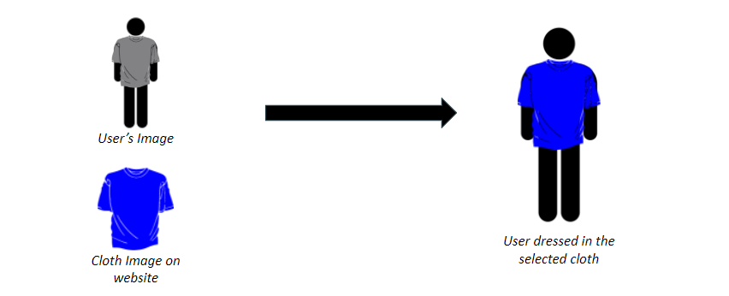

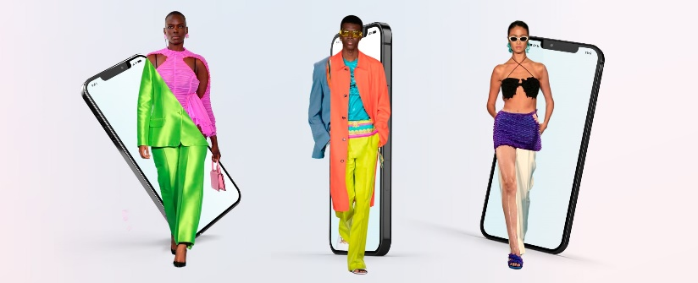

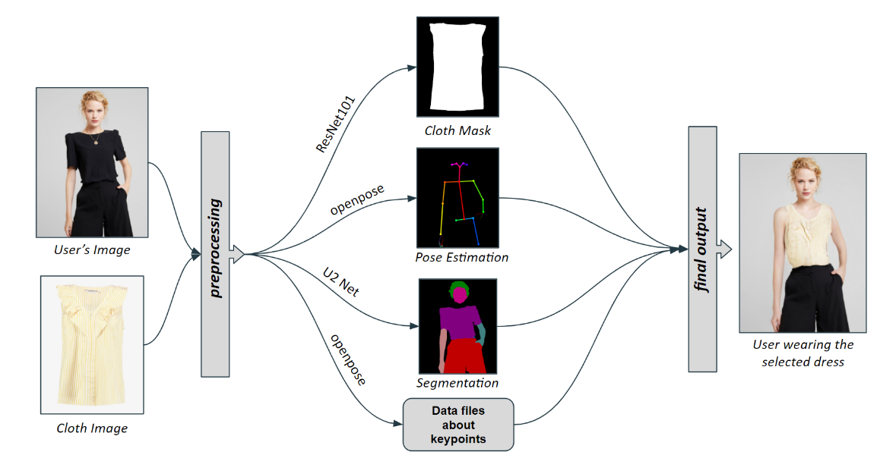

**CHAPTER 5**

**CONCLUSION**

The development of a virtual clothing try-on application requires a range of tools and technologies, including UI/UX design tools, 3D modeling software, virtual try-on platforms, and VR/AR integration tools. The project budget and services costs can vary widely depending on the scope of the project, technology used, and development time required. However, the benefits of a virtual clothing try-on application, such as increased customer engagement, improved user experience, and higher conversion rates, make it a worthwhile investment for online retailers and fashion brands.

Overall, a virtual clothing try-on application has the potential to transform the online shopping experience and provide users with a more personalized and engaging way to shop for clothes online. With the growing demand for online shopping and the advancements in technology, virtual clothing try-on applications are likely to become more popular and widespread in the future.

**REFERENCES**

1. **"Virtual Try-On Technology for Apparel Design and Retailing,"** by Y. Cho and J. Kim, published in the Journal of Fashion Marketing and Management: An International Journal.
2. **"Virtual Try-On: A Critical Review,"** by P. Chattopadhyay and S. S. Hasan, published in the Journal of Electronic Commerce Research.
3. **"Virtual Try-On Applications in the Fashion Industry,"** by D. Öğüdücü and S. Akgül, published in the Journal of Textile and Apparel, Technology and Management.
4. **"Virtual Try-On Systems: A Review,"** by M. Peñaloza and M. Gallardo, published in the Journal of Virtual Reality and Broadcasting.
5. "**Augmented Reality in Clothing”:** A Virtual Try-On Experience," by N. Kumar and A. Kumar, published in the Journal of Textile Engineering & Fashion Technology.

**CODE**

https://github.com/Srija444/Virtual-clothing-try-on.git